Specifications

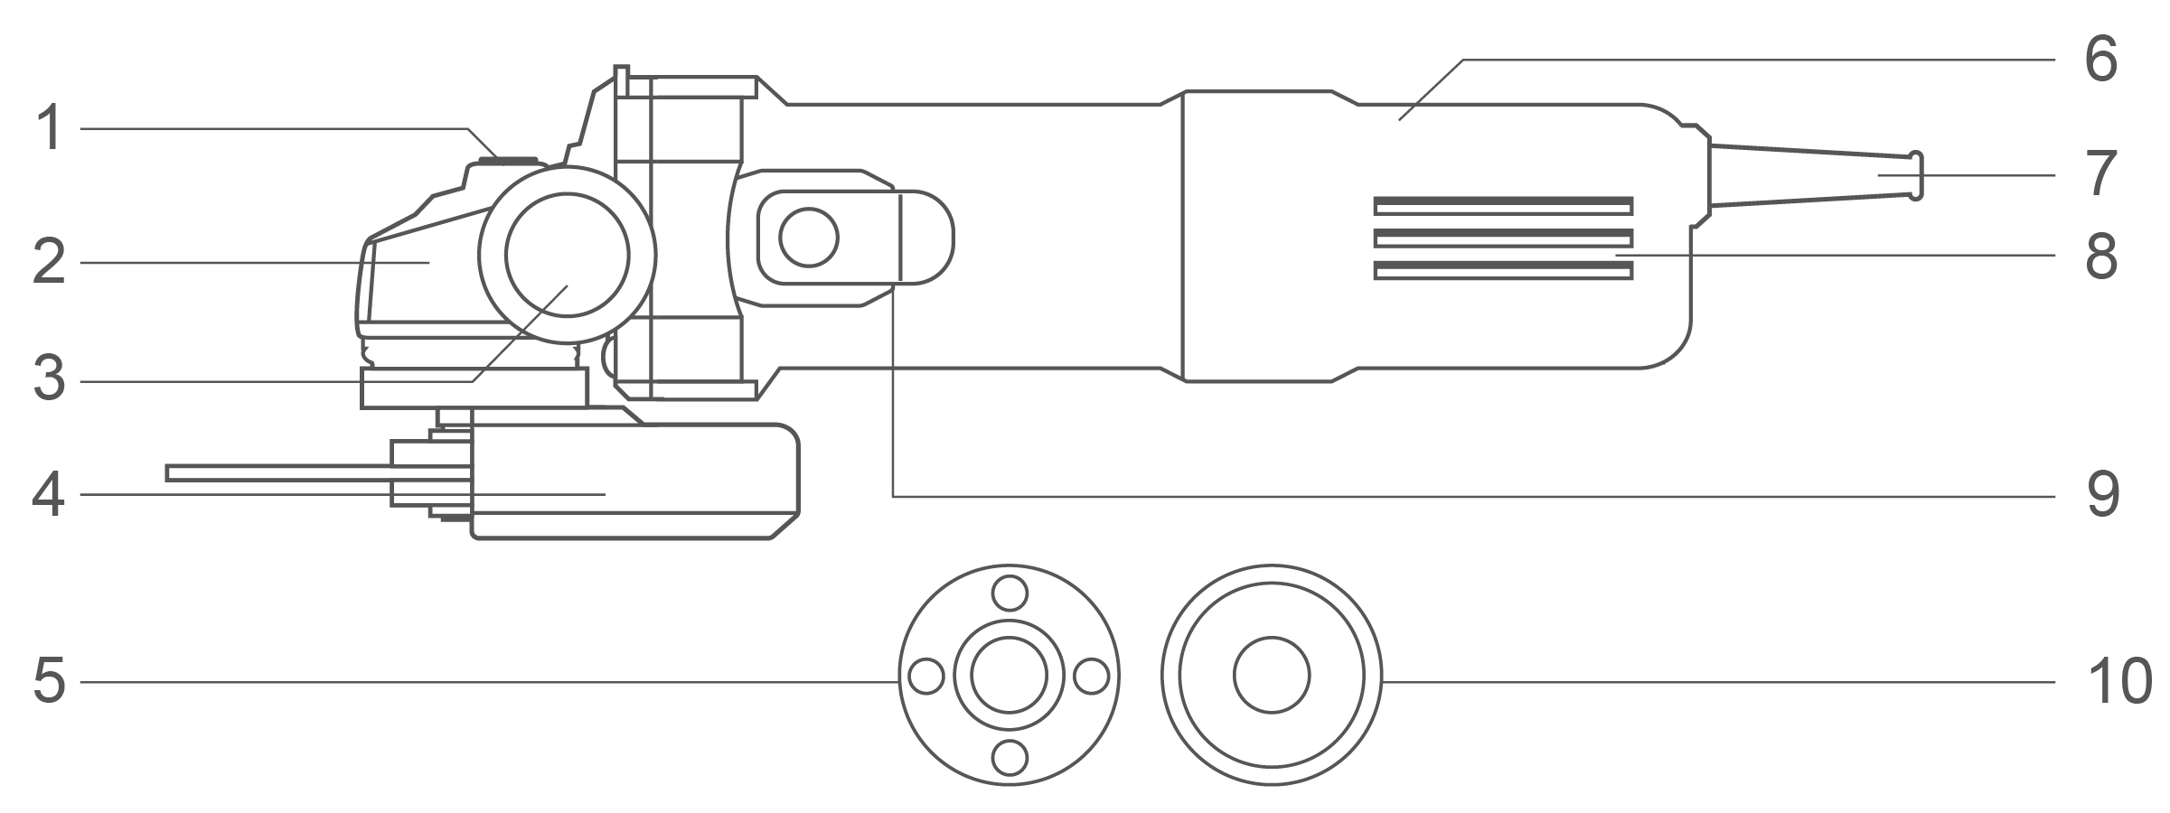

**Components**

|  |  |
| --- | --- |
| 1. Spindle locking button 2. Aluminum gear box 3. Auxiliary handle 4. Disc guard 5. Thread lock flange | 1. Housing 2. Power cable sleeve 3. Cooling vents 4. On/off switch button 5. Mounting washer flange |

Accessories

1. Auxiliary handle 1pcs
2. Spanner 1pcs

Technical specifications

|  |  |  |
| --- | --- | --- |
| Model No. | AG75028  AG75028xy | UAG75028  UAG75028xy |
| **Rated input power** | 750W | 750W |
| **Rated voltage** | 220-240V~50/60Hz | 110-120V~50/60Hz |
| **Rated no-load speed** | 12000/min | 12000/min |
| **Grinding spindle thread** | M14 | 5/8˝-11UNC |
| **Disc diameter** | 115mm | 4-1/2˝ |
| **Protection class** | 回/II | 回/II |

|  |  |  |
| --- | --- | --- |
| Model No. | AG75028-9  （INMETRO Plug） | UAG75028-91  （INMETRO Plug） |
| **Rated input power** | 750W | 750W |
| **Rated voltage** | 220-240V~60Hz | 127V~60Hz |
| **Rated no-load speed** | 12000/min | 12000/min |
| **Grinding spindle thread** | M14 | M14 |
| **Disc diameter** | 115mm | 4-1/2˝ |
| **Protection class** | 回/II | 回/II |

|  |  |  |
| --- | --- | --- |
| Model No. | AG75028-8E | AG750283 |
| **Rated input power** | 750W | 750W |
| **Rated voltage** | 220-240V~50/60Hz | 220-240V~50/60Hz |
| **Rated no-load speed** | 12000/min | 12000/min |
| **Grinding spindle thread** | M14 | M10 |
| **Disc diameter** | 115mm | 100mm |
| **Protection class** | 回/II | 回/II |

**Model No. NOTE:** x (blank, 1,2,3,4,5,6,7,8,9,E,S,A,M); y (blank, -1,-2,-3,-4,-5,-6,-7,-8,-9,E,S,A,M)

* Due to our continuing program of research and development, the specifications herein are subject to change without notice.

**Noise/Vibration information**

The noise emission, measured in accordance with EN62841-2-3:

|  |  |  |
| --- | --- | --- |
| Sound pressure level | LpA | 94 dB (A) |
| Sound power level | LwA | 102 dB (A) |
| Uncertainty | K | 3 dB (A) |

**Wear hearing protection!**

The vibration total value and its uncertainty determined according to EN62841-2-3:

**Surface grinding:**

|  |  |  |
| --- | --- | --- |
| Vibration emission value | ah,AG | 9,3 m/s2 |
| Uncertainty | K | 1,5 m/s2 |

**NOTE:** For other applications, e.g., abrasive cutting-off operations or wire brushing other vibration values could occur.

That the declared vibration total value has been measured in accordance with a standard test method and may be used for comparing one tool with another.

That the declared vibration total value may also be used in a preliminary assessment of exposure.

**⚠ WARNING!**

* **That the vibration emission during actual use of the power tool can differ from the declared total value depending on the ways in which the tool is used;**
* **Identify safety measures to protect the operator that are based on an estimation of exposure in the actual conditions of use (taking account of all parts of the operating cycle such as the times when the tool is switched off and when it is running idle in addition to the trigger time).**